SOC Simulation Report
Introduction to Phishing Analysis
TryHackMe — Alert Triage & Incident Analysis | 04/14/2026
Overview
This report documents the analysis of four security alerts generated during the TryHackMe SOC Simulation — Introduction to Phishing scenario. As the assigned SOC Analyst, each alert was triaged, investigated, and classified as either a True Positive (TP) or False Positive (FP) based on threat intelligence, firewall logs, and email analysis.

Total Alerts | True Positives | False Positives | Escalated
4 | 2 | 2 | 1

Alert 1 — Blacklisted URL Access Attempt
✅ Verdict: TRUE POSITIVE — Blocked | No Escalation Required

Alert Details
Alert Type | Outbound connection to blacklisted URL
Time | 04/14/2026 00:42:06.773
Hostname | win-3457
User | Hannah Harris
Source IP | 10.20.2.17
Destination IP | 67.199.248.11
Blocked By | Firewall / Proxy

Analysis
The alert was triggered when workstation win-3457 attempted to reach an external URL that appears in the organization’s threat intelligence blacklist. The URL was a shortened bit.ly link — a common obfuscation technique used by attackers to hide malicious destinations from URL-filtering tools.
The destination IP (67.199.248.11) was validated against VirusTotal and confirmed to be associated with malicious activity. The firewall successfully blocked the connection before it was established, preventing any data exchange with the malicious host.

Why True Positive
- Destination IP flagged as malicious on VirusTotal
- URL uses bit.ly shortening — known obfuscation technique
- Domain appears on the organization’s threat intelligence blacklist

Why No Escalation
- Firewall blocked the connection — no data was exchanged
- No evidence of successful outbound communication
- No lateral movement or follow-up activity observed

Recommended Actions
- Provide targeted user awareness training to Hannah Harris on phishing link recognition
- Confirm the bit.ly destination resolves to the malicious IP across threat intel feeds
- Review proxy logs for any similar bit.ly accesses from other endpoints

Indicators of Compromise (IOCs)
Indicator Type | Value
IP Address | 67.199.248.11
URL | http://bit.ly/3sHkX3da12340

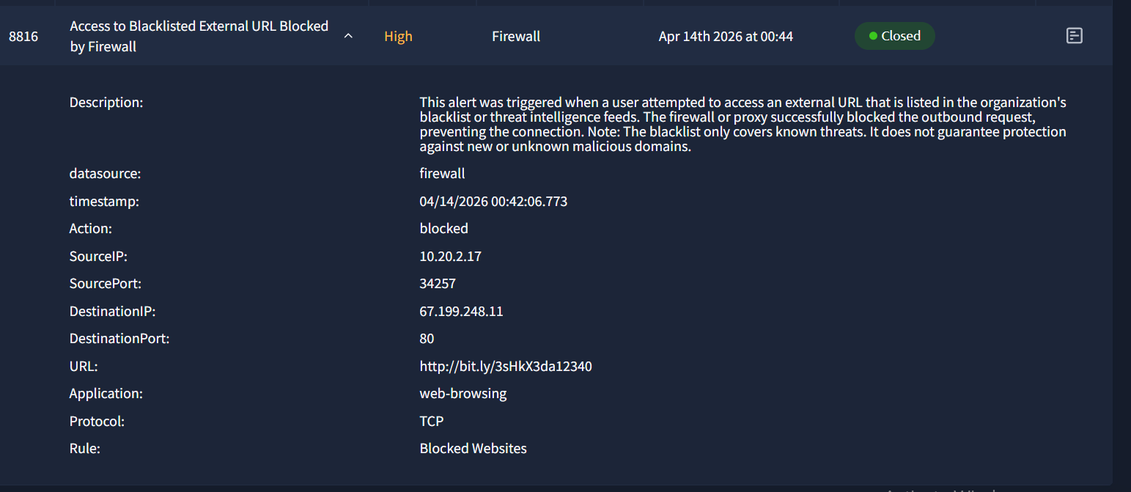

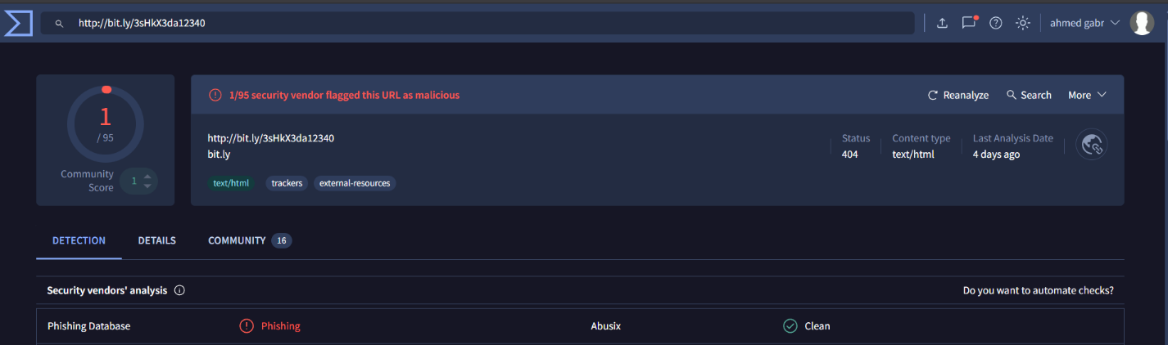

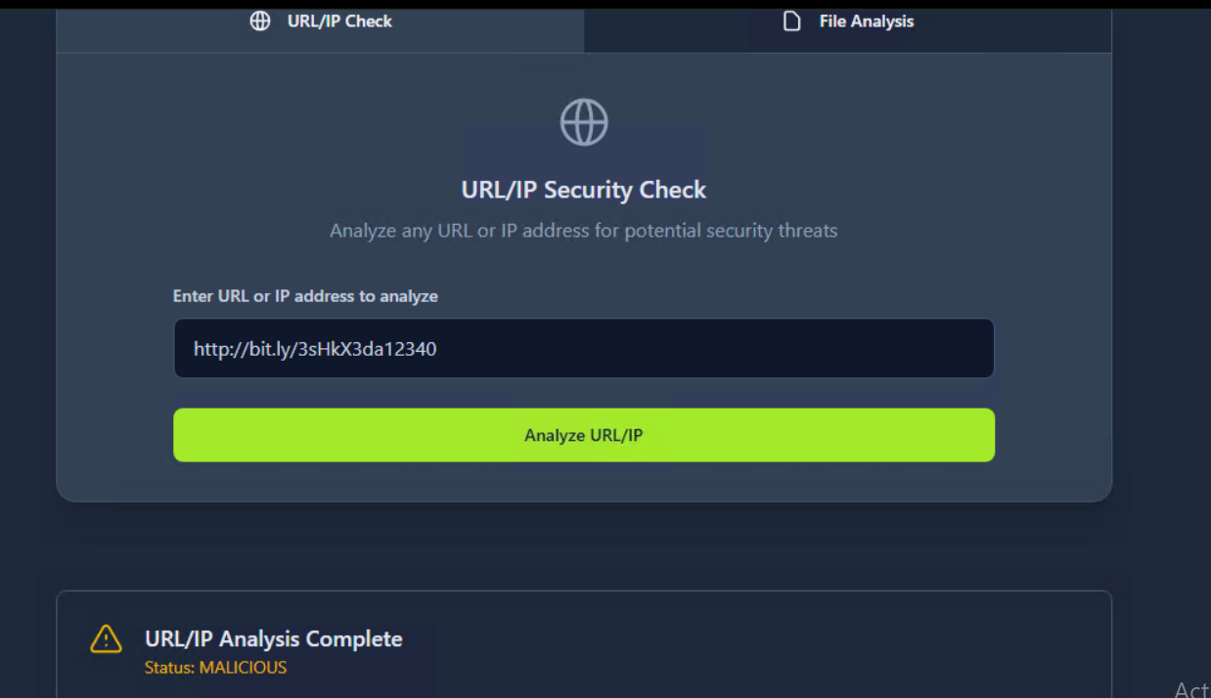

Alert 2 — Inbound Email with External Link
⚠️ Verdict: FALSE POSITIVE — Legitimate Onboarding Email

Alert Details
Alert Type | Inbound email with external link
Time | 04/14/2026 04:24:43.565
Hostname | win-3452
User | Julia Garcia
Recipient | j.garcia@thetrydaily.thm
Sender | onboarding@hrconnex.thm

Analysis
This alert was triggered by an inbound email sent from onboarding@hrconnex.thm to Julia Garcia on win-3452. The email contained an external link which was checked against VirusTotal and other threat intelligence platforms — no malicious indicators were found.
While the email exhibits some suspicious characteristics (external sender domain, urgency in language), these are consistent with legitimate HR onboarding communications. No evidence of user interaction with any link was observed at the time of analysis.

Why False Positive
- URL not flagged as malicious on any threat intelligence platform
- Sender domain (hrconnex.thm) appears to be a legitimate HR system
- No firewall or proxy logs indicate the user accessed the URL
- No follow-up suspicious activity observed on win-3452

Analyst Notes
Although classified as a False Positive, this alert warrants a note: the use of urgency language and an external domain are phishing indicators worth monitoring. Recommend continued watch on similar emails from this sender.


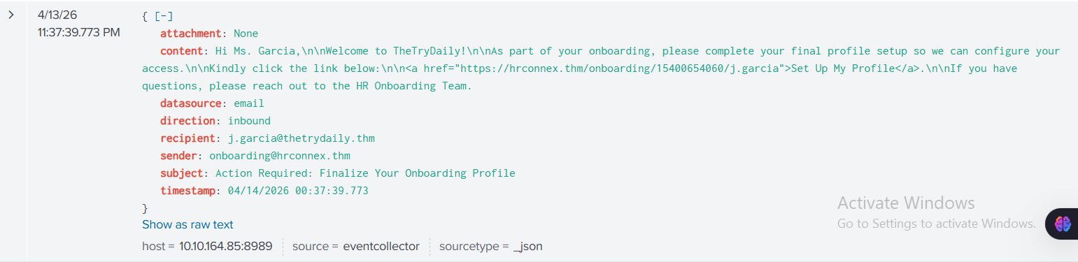

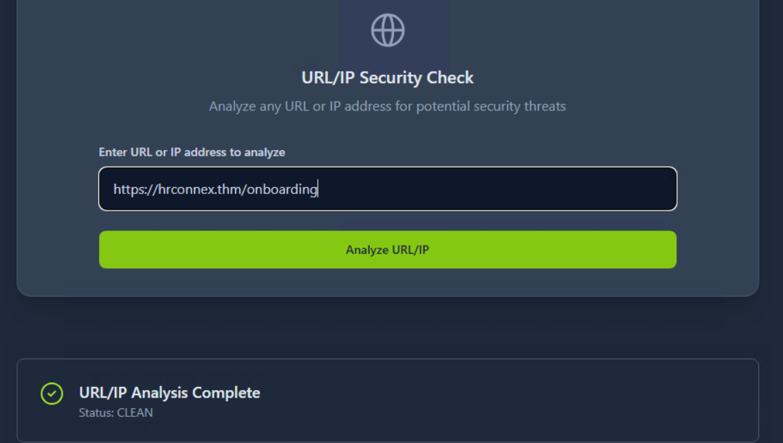

Alert 4 — Phishing Email: Microsoft Typosquatting
🚨 Verdict: TRUE POSITIVE — ESCALATED | User Clicked Phishing Link

Alert Details
Alert Type | Inbound phishing email with confirmed user interaction
Time | 04/14/2026 00:43:10.773
Hostname | win-3463
User | Charlotte Allen
Source IP | 10.20.2.25
Recipient | c.allen@thetrydaily.thm
Sender | no-reply@m1crosoftsupport.co
Phishing URL | https://m1crosoftsupport.co/login
Dest. IP | 45.148.10.131

Analysis
This is the most critical alert in this investigation. Charlotte Allen on win-3463 received an email from no-reply@m1crosoftsupport.co — a typosquatted domain impersonating Microsoft Support by replacing the letter ‘o’ with the number ‘1’ (m1crosoftsupport vs microsoftsupport).
The destination IP (45.148.10.131) was confirmed malicious on VirusTotal. Critically, firewall and proxy logs confirm that Charlotte Allen actively clicked the phishing link and accessed https://m1crosoftsupport.co/login from win-3463. This constitutes a confirmed phishing compromise event with high risk of credential theft.

Why True Positive
- Sender domain uses typosquatting: ‘m1crosoftsupport.co’ impersonates Microsoft
- Destination IP (45.148.10.131) flagged as malicious on VirusTotal
- Firewall logs confirm user accessed the phishing login page
- No legitimate Microsoft communication uses m1crosoftsupport.co

Why Escalated
- User (Charlotte Allen) confirmed to have clicked the phishing link
- Login page accessed — high risk of credential compromise
- Potential for account takeover and lateral movement
- Immediate containment required to prevent further damage

Recommended Remediation Actions
- ISOLATE win-3463 immediately from the network
- Perform a full endpoint scan on win-3463 for malware or credential stealers
- Reset Charlotte Allen’s credentials across all systems
- Block all malicious indicators (IP, domain, URL) across firewall, proxy, and DNS
- Review Active Directory for any unauthorized login attempts using her credentials
- Provide urgent phishing awareness training to Charlotte Allen

Indicators of Compromise (IOCs)
Indicator Type | Value
Sender Email | no-reply@m1crosoftsupport.co
Phishing Domain | m1crosoftsupport.co
Phishing URL | https://m1crosoftsupport.co/login
Destination IP | 45.148.10.131
Technique | Typosquatting — Microsoft impersonation
Affected Host | win-3463 (Charlotte Allen, 10.20.2.25)
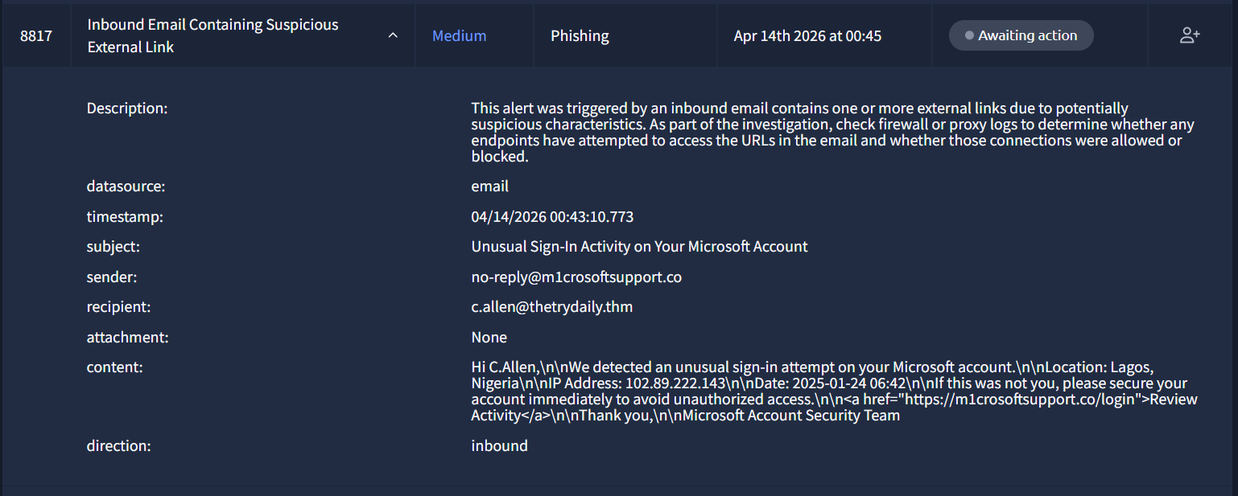

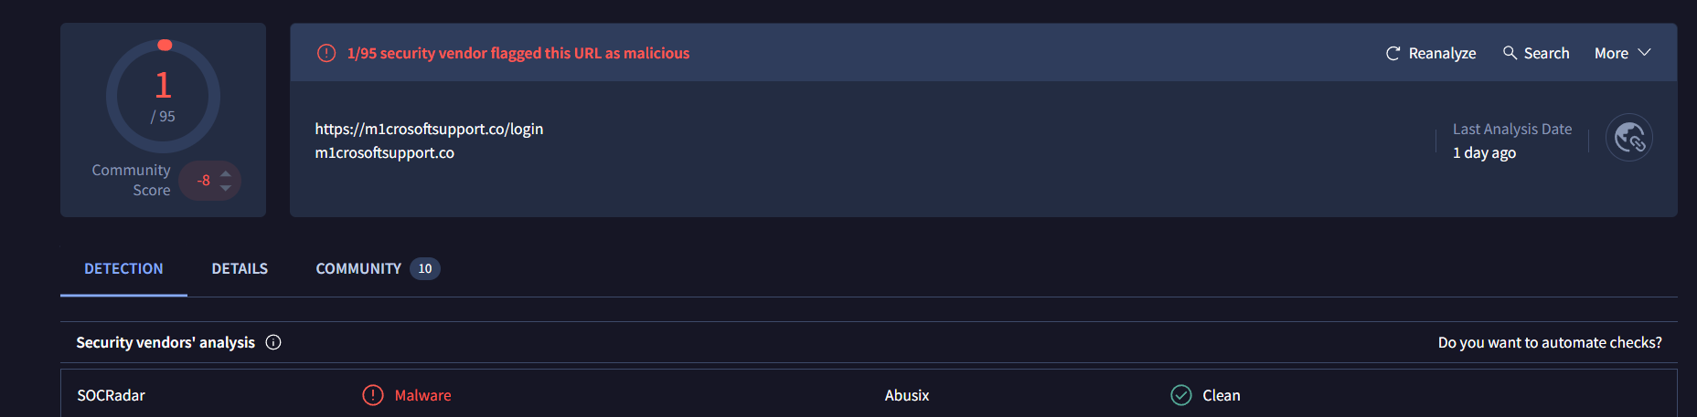

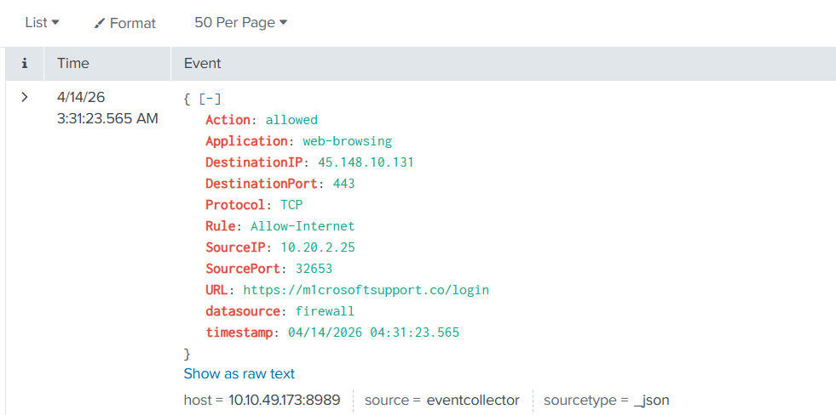

Investigation Summary

# | Alert Type | Affected User | Verdict | Escalated | Action
1 | Blacklisted URL Access | Hannah Harris | TRUE POS. | No | User awareness
2 | Email w/ External Link | Julia Garcia | FALSE POS. | No | Monitor
3 | Email w/ External Link | Julia Garcia | FALSE POS. | No | Monitor
4 | Phishing / Typosquatting | Charlotte Allen | TRUE POS. | YES ★ | Isolate + Reset

Master IOC List
Indicator Type | Value
IP Address | 67.199.248.11 (Alert 1 — blocked)
URL | http://bit.ly/3sHkX3da12340 (Alert 1)
Sender Email | no-reply@m1crosoftsupport.co (Alert 4)
Domain | m1crosoftsupport.co (Alert 4)
Phishing URL | https://m1crosoftsupport.co/login (Alert 4)
IP Address | 45.148.10.131 (Alert 4 — user accessed)

Skills Demonstrated
- Alert Triage — classified 4 alerts as TP/FP using structured analysis methodology
- Phishing Email Analysis — identified typosquatting, obfuscated URLs, and sender spoofing
- Threat Intelligence — used VirusTotal to validate IPs and URLs against known malicious indicators
- Firewall & Proxy Log Analysis — confirmed blocked vs. successful connections per endpoint
- Incident Escalation — identified and escalated credential compromise risk with remediation plan
- IOC Documentation — extracted and catalogued all indicators across the investigation
- Case Reporting — produced structured case reports with verdict justification for each alert

Completed on TryHackMe | SOC Simulation: Introduction to Phishing | Blue Team / SOC L1

